FIS URL's -

**FNFIS URL:** <https://ssp.fnfis.com/login>

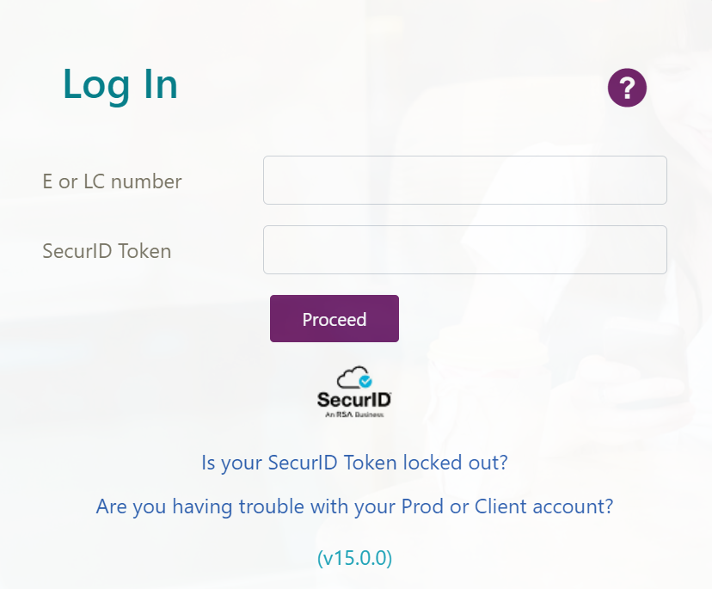

**MyApps:**[My Apps (microsoft.com)](https://myapps.microsoft.com/)

**FIS Career Hub :** [Careers at FIS (fisglobal.com)](https://careers.fisglobal.com/i/us/en/home)

**Workday portal:** [Home - Workday (myworkday.com)](https://wd5.myworkday.com/fis/d/home.htmld)



**WeLearn Portal:** [Learning @ FIS: Home (sabacloud.com)](https://fisglobal.sabacloud.com/Saba/Web_spf/NA10P1PRD002/app/dashboard)

**Planview Portal:** <https://fisglobal.pvcloud.com/planview/Track/Time/>

**Health Insurance Portal:**[Vidal Health Insurance (vidalhealthtpa.com)](https://vidalhealthtpa.com/employeeportal/home)



Ticketing URL's:

**Service now:** <https://atyourserviceportal.service-now.com/now/nav/ui/classic/params/target/welcomePage.do>



**Service request:** <https://atyourserviceportal.service-now.com/supportall>



**Jira:** <https://jira.fis.dev/login.jsp>?



**Dash Request:** <https://dash.fisglobal.com/Request/Default.aspx>



**Wso2 vendor ticket request:** <https://support.wso2.com/support>



**VFP Request portal:** [RMIS (fnfis.com)](https://rmis.fnfis.com/)



IST_SaaS project URL's:

**Wiki Page:** <https://wiki.fnis.com/pages/viewpage.action>?

**Azure Portal:** <https://portal.azure.com/#home>



**Dynatrace Login:** <https://zpl24448.live.dynatrace.com/ui/dashboards?gf=all>



**Splunk Login:**<https://splunk.fnfis.com/en-US/account/login>?



**Keyfactor Login:** <https://fis.keyfactorpki.com/Keyfactor/Portal>



**Service now IST_SaaS Dashboard:** <https://atyourserviceportal.service-now.com/$pa_dashboards_overview.do>

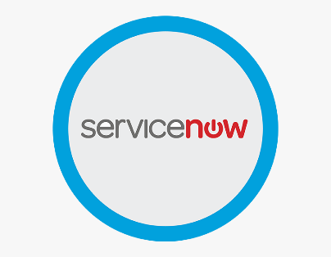

**NETXMS UAT:** [FIS Payments Monitor (fisglobal.com)](https://netxms-one-retail-uat.fisglobal.com/pm)



ISTGUI URL's:

**Chevron Prod IST GUI URL -**

**East:** <https://10.18.94.163/IST-Switch/>

**West:** <https://10.18.93.163/IST-Switch/>



**Paypal Prod IST GUI URL -**

**South East:** <https://10.18.66.163/IST-Switch/>

**East:** <https://10.18.66.35/IST-Switch/>



**Intuit Prod IST GUI URL -**

**East:** <https://10.18.103.35/IST-Switch/login.jsp>

**West:** <https://10.18.102.35/IST-Switch/login.jsp>



**Mastercard Prod IST GUI URL -**

**East:**<https://prodgui/IST-Switch/login.jsp>

**West:** <https://prod2gui/IST-Switch/>

CrushFTP URL's:

**Paypal: East**

http://10.18.66.22:8080/WebInterface/login.html

<http://10.18.66.23:8080/WebInterface/login.html>

**Paypal : Southeast**

http://10.18.66.150:8080/WebInterface/login.html

[http://10.18.66.151:8080/WebInterface/login.html](http://10.18.66.23:8080/WebInterface/login.html)



**Intuit : East**

http://10.18.103.22:8080/WebInterface/login.html

http://10.18.103.23:8080/WebInterface/login.html

**Intuit : West**

http://10.18.102.22:8080/WebInterface/login.html

http://10.18.102.23:8080/WebInterface/login.html



**Chevron: East**

http://10.18.94.150:8080/WebInterface/login.html

http://10.18.94.151:8080/WebInterface/login.html

**Chevron: West**

http://10.18.93.150:8080/WebInterface/login.html

http://10.18.93.151:8080/WebInterface/login.html



**CrushFTP Admin URL:** <http://10.95.135.200:8080/WebInterface/login.html?link=/WebInterface/admin/index.html>

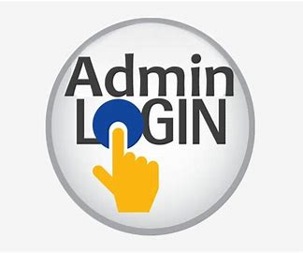

**PP EU CrushFTP URL:**

http://10.95.61.69:8080/WebInterface/login.html

http://10.95.61.70:8080/WebInterface/login.html



**PP Central US CrushFTP URL:**

http://10.95.61.101:8080/WebInterface/login.html

http://10.95.61.102:8080/WebInterface/login.html



**Chevron MAS Prod CrushFTP URL:**

http://10.95.135.233:8080/WebInterface/login.html

http://10.95.135.234:8080/WebInterface/login.html

http://10.95.130.233:8080/WebInterface/login.html

http://10.95.130.234:8080/WebInterface/login.html



SharePoint URLs :

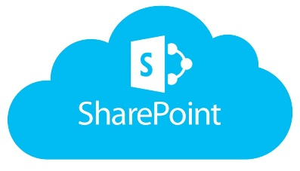

**Shift Roster:** [ISTSaaSTeam_ShiftRoster_2024.xlsx (sharepoint.com)](https://fisglobal.sharepoint.com/:x:/r/teams/ISTSaaSServiceDelivery/_layouts/15/Doc.aspx?sourcedoc=%7BE28D412F-E746-4E75-9ADF-380A60965A9A%7D&file=ISTSaaSTeam_ShiftRoster_2024.xlsx&action=default&mobileredirect=true)

**Certificate Passwords:** [TLS_Certificate_passwords.xlsx (sharepoint.com)](https://fisglobal-my.sharepoint.com/:x:/r/personal/tharunkumar_thonangi_fisglobal_com/_layouts/15/doc2.aspx?sourcedoc=%7B590A2D69-311E-46C1-ABA0-6A11A9247AAE%7D&file=TLS_Certificate_passwords.xlsx&action=default&mobileredirect=true&DefaultItemOpen=1%3Fweb%3D1)

**DB Passwords:** [DB_passwords_New_2023_All_Clients.xlsx (sharepoint.com)](https://fisglobal.sharepoint.com/:x:/r/teams/ISTSaaSServiceDelivery/_layouts/15/Doc.aspx?sourcedoc=%7B78ECCD43-5E19-41E3-A67F-13F80D56B9E1%7D&file=DB_passwords_New_2023_All_Clients.xlsx&action=default&mobileredirect=true)

**Server List:** [ISTSAASSUPPORTTEAM_server_list.xlsx (sharepoint.com)](https://fisglobal.sharepoint.com/:x:/r/teams/ISTSaaSServiceDelivery/_layouts/15/Doc.aspx?sourcedoc=%7BC5C8E7D9-35E1-40D8-B7D6-39E23AF92AC5%7D&file=ISTSAASSUPPORTTEAM_server_list.xlsx&action=default&mobileredirect=true&isSPOFile=1&clickparams=eyJBcHBOYW1lIjoiVGVhbXMtRGVza3RvcCIsIkFwcFZlcnNpb24iOiI0OS8yNDA1MzEwMTQyMSIsIkhhc0ZlZGVyYXRlZFVzZXIiOmZhbHNlfQ%3D%3D)

**Certificate details:** [Certificate_Inventory_Chevron_Intuit_MC.xlsx (sharepoint.com)](https://fisglobal.sharepoint.com/:x:/r/teams/ISTSwitchSaaS/_layouts/15/Doc.aspx?sourcedoc=%7B00728268-EF16-4B96-90D0-671AF2BCE956%7D&file=Certificate_Inventory_Chevron_Intuit_MC.xlsx&action=default&mobileredirect=true&wdsle=0)

**NETXMS New VM’s:** [IST Switch SaaS - Netxms_new_VM_details.txt - All Documents (sharepoint.com)](https://fisglobal.sharepoint.com/teams/ISTSwitchSaaS/Shared%20Documents/Forms/AllItems.aspx?csf=1&web=1&e=9u58p9&CID=f50c6a4d%2D15c7%2D4111%2D93fc%2D5bbb745ba57c&FolderCTID=0x0120003F0BC3DDA9CE4841AF372F1026771823&id=%2Fteams%2FISTSwitchSaaS%2FShared%20Documents%2FDocuments%2FNetxms%5Fnew%5FVM%5Fdetails%2Etxt&viewid=578e7297%2Df51e%2D4625%2D88c6%2D57a561c40e1a&parent=%2Fteams%2FISTSwitchSaaS%2FShared%20Documents%2FDocuments)

**Recurring Issue tracker:** [IST_SaaS_Recurring_Issue.xlsx (sharepoint.com)](https://fisglobal-my.sharepoint.com/:x:/r/personal/aravind_krishna_fisglobal_com/_layouts/15/Doc.aspx?sourcedoc=%7B538ea1cf-cdf6-4c17-8861-8cef08b97ee8%7D&action=edit&wdnewandopenct=1720774214294&wdorigin=OFFICECOM-WEB.START.NEW&wdprevioussessionsrc=HarmonyWeb&wdprevioussession=beb3713b-fde3-4158-bef0-bddf8eab5e28&wdenableroaming=1&wdodb=1&wdlcid=en-US&wdhostclicktime=1720774215059&wdredirectionreason=Force_SingleStepBoot&wdinitialsession=92aa18f3-3195-549c-8e3b-f8a882496f14&wdrldsc=2&wdrldc=1&wdrldr=ContinueInExcel&CID=FF37C546-C5B6-42AD-AB41-8EE7C3C92FC1&wdLOR=c4FBE9861-4B10-448E-A0E2-D6E3EB60F4AD)

**Weekly update tracker:** [Weekly updates.xlsx (sharepoint.com)](https://fisglobal-my.sharepoint.com/:x:/r/personal/prashant_n_narayan_konnur_fisglobal_com/_layouts/15/Doc.aspx?sourcedoc=%7B1834B1FC-74EA-4F2F-8B35-95014464C086%7D&file=Weekly%20updates.xlsx&wdOrigin=TEAMS-MAGLEV.p2p_ns.rwc&action=default&mobileredirect=true)

**MPMS architecture:** [2022 MPMS - Architecture diagrams - All Documents (sharepoint.com)](https://fisglobal.sharepoint.com/teams/2022MPMS/Shared%20Documents/Forms/AllItems.aspx?csf=1&web=1&e=QKEcD0&CID=035caf3e%2Dc0b0%2D4257%2Dac65%2Df99df70cda8e&FolderCTID=0x012000672AAF65DFD44448A4285844882B555E&id=%2Fteams%2F2022MPMS%2FShared%20Documents%2FDelivery%2F11%20Integration%2F02%20Project%20Delivery%2F02%20Build%2FArchitecture%20diagrams)